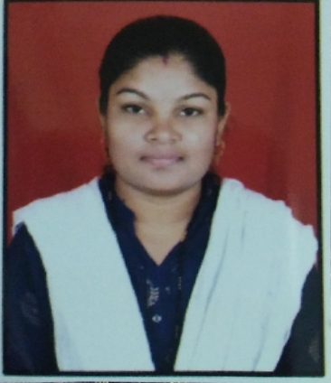

Name: - Mrs. Dagadkhair Bhagyashri Mhatardev.
Designation: - Assistant Professor in Chemistry
- Personal Information:-
- DOB :- 30th January 1996
- Sex :- Female
- Status :- married
- Address :-At post Shevgaon, Tal-Shevgaon,
Dist-Ahmednagar 414502
- Email Id :- bhagyashridagadkhair01@gmail.com
- Mob No- 7887337765
- Educational Qualification:-
Sr.No. | Degree | University | Year of Passing
1 | B.Sc.(Chemistry) | S.P.P.U. Pune | 2016
2 | M.Sc.(Analytical Chemistry) | S.P.P.U. Pune | 2018

Other Qualification:
- MS-CIT
- Experience :
- 1 years teaching experience at UG level.

